Access Form
Software Requirements Specification

Version 1.0



Group Id: F25PROJECT7C1CA (BC220404835)
Supervisor Name: Abdullah Qamar

Revision History

Date  (dd/mm/yyyy) | Version | Description | Author
03/12/2025 | 1.0 | “AccessForm” is a web-based survey builder application designed with accessibility as its core focus. The system aims to provide an inclusive platform where users can create, publish, and respond to surveys in a fully accessible environment. Unlike traditional form builders, AccessForm follows WCAG 2.1 guidelines and ensures support for screen readers, keyboard navigation, high-contrast themes, and dyslexia-friendly viewing modes. The project also introduces alternative response methods such as voice input and SMS-based participation, enabling users with visual, motor, or cognitive impairments to interact with surveys easily. Overall, AccessForm focuses on creating an accessible, user-friendly, and adaptable survey creation and response system. | bc220404835

Table of Contents

1. Scope of the Project 4
1.1 Purpose 5
1.2 Definitions, Acronyms, and Abbreviations 5
2. Functional Requirements and Non-Functional Requirements: 6
2.1 Functional Requirements 6
2.2 Non-Functional Requirements 7
3. Use Case Diagram: 9
4. Usage Scenarios: 10
4.1 UC-01 — Login to System 10
4.2 UC-02 — Manage Users (Create, Update, Delete) 11
4.3 UC-03 — Monitor Surveys & Respondent Activities 11
4.4 UC-04 — Verify Accessibility Compliance 12
4.5 UC-05 — Manage System Settings 12
4.6 UC-06 — View System Analytics 13
4.7 UC-07 — Login / Sign Up / Register 13
4.8 UC-08 — Create Survey 14
4.9 UC-09 — Add / Edit / Delete Questions 14
4.10 UC-10 — Apply Accessibility Settings 15
4.11 UC-11 — Publish Survey 16
4.12 UC-12 — Distribute Survey 16
4.13 UC-13 — View Survey Responses 17
4.14 UC-14 — Generate Analytics Report 17
4.15 UC-15 — Export Data (CSV, Excel, PDF) 18
4.16 UC-16 — Delete Survey 18
4.17 UC-17 — Access Survey 19
4.18 UC-18 — Navigate via Keyboard 19
4.19 UC-19 — Use Accessibility Settings 20
4.20 UC-20 — Submit Responses (includes Web, SMS, Voice Methods) 20
4.21 UC-21 — Receive Confirmation Message 21
5. Adopted Methodology 23
5.1 Waterfall Model 23
5.2 Spiral Model 24
5.3 VU process Model 26
5.4 Reasons for choosing the Methodology 27
6. Work Plan (Use MS Project to create Schedule/Work Plan) 28
6.1 Work Plan 28
6.2 Detailed Project Schedule: 28

SRS Document

Introduction
The introduction of this Software Requirements Specification is that it provides an overview of the AccessForm project, highlighting its purpose, scope, objectives, and accessibility-driven design philosophy. The goal of this document is to analyze and define the survey system’s requirements in detail, ensuring that the application meets the usability and accessibility needs of all stakeholders, including administrators, form creators, and respondents. This SRS also outlines the system’s high-level features, architecture expectations, user roles, and essential accessibility components that guide the development process.

Scope of the Project
AccessForm is a fully accessible web-based survey builder developed to promote inclusive participation for all users, including individuals with visual, auditory, cognitive, or motor impairments. Unlike traditional survey platforms, AccessForm follows WCAG 2.1 accessibility guidelines to ensure that every user can create, respond to, and manage surveys without facing usability barriers.
The system consists of three main roles:
- Admin (manages users, surveys, accessibility compliance, and system analytics)
- Form Creator (creates accessible surveys and views responses)
- Respondent (responds to surveys via web, voice, or SMS)
The application will provide an accessibility-focused interface for building surveys using drag-and-drop components, supporting various question types such as multiple-choice, text inputs, rating scales, and file uploads. Special emphasis is placed on WCAG 2.1 and ARIA practices, enabling keyboard-only navigation, screen-reader support, high-contrast themes, dyslexia-friendly display modes, captioned and sign-language videos and alternative text (alt text) for all multimedia elements.
The scope of the project further includes multiple response methods, such as standard web responses, voice-based responses through speech-to-text technologies, and SMS-based survey submission for users with limited internet connectivity. An accessible analytics dashboard will allow form creators to review results through screen-reader-friendly graphs, tables, and exportation in multiple formats downloadable reports.
Overall, AccessForm seeks to create an inclusive environment where survey creation and participation are barrier-free. The platform will be developed following accessibility guidelines throughout all stages—design, implementation, testing, and evaluation ensuring that the final product meets the needs of diverse user groups.

Purpose

The purpose of this SRS document is to provide a detailed description of AccessForm and its required features from an accessibility-first perspective. It outlines the system’s functionality, user interactions, constraints, and design goals to ensure that the application supports users with varying abilities. This document helps establish a clear understanding among developers, stakeholders, and evaluators regarding the system’s intended behavior, accessibility expectations, and technical requirements.
It will also act as a reference guide during the entire Software Development Life Cycle (SDLC), ensuring that we follow WCAG 2.1, ARIA practices, and usability standards while implementing and validating the system.

Definitions, Acronyms, and Abbreviations

Term | Definition
WCAG (Web Content Accessibility Guidelines) | A set of international standards that ensure web content is accessible to people with disabilities.
ARIA (Accessible Rich Internet Applications) | A framework that makes dynamic web content more accessible to screen readers.
Alt Text (Alternative Text) | Descriptive text added to images and multimedia to support screen-reader users.
A11y | Short form of the word “Accessibility,” representing 11 hidden letters

Functional Requirements and Non-Functional Requirements:

Functional Requirements
Following are the key functional requirements of the proposed AccessForm – Accessible Survey Builder Web Application:

1. User Accounts & Authentication
- Admin login
- Form Creator signup/login
- Respondent optional login (if required by form creator)
- Secure authentication with validation

2. Admin Panel Features
- Manage users (create, update, delete form creators)
- Monitor all forms created on the system
- Monitor respondent activity
- Approve or flag forms not meeting accessibility guidelines
- View system-wide analytics
- Export system reports (PDF/CSV)

3. Form Creator Panel
- Create accessible survey forms
- Drag-and-drop form builder
- Add multiple question types:
  - MCQs
  - Text input
  - Rating scales
  - File upload
- Apply accessibility options:
  - High contrast mode
  - ARIA labels
  - Alt text for images
  - Dyslexia-friendly font
  - Screen reader–friendly structure
  - Captions for video questions
- Preview form before publishing
- Distribute form via link, QR, SMS
- View responses
- Export responses (CSV, Excel, PDF)

4. Respondent Panel
- Fill surveys via:
  - Web browser
  - Voice input (speech-to-text)
  - SMS input
- Adjust accessibility settings such as:
  - High contrast
  - Font size adjustments
  - Screen reader mode
- Submit responses
- Receive confirmation

5. Analytics & Reporting
- Generate accessible graphs and tables
- Screen-reader-friendly charts
- Voice-based summary (optional)

Non-Functional Requirements

1. Accessibility
- The system must follow WCAG 2.1 accessibility guidelines.
- Full keyboard navigation
- Screen reader support
- High-contrast, large-text, and dyslexia-friendly mode selection
- ARIA attributes must be implemented

2. Usability
- Simple user interface
- Clear navigation
- Accessibility settings must always be visible

3. Graphical User Interface
- The system shall maintain a uniform, intuitive, and accessible interface across all modules.
- All icons, buttons, and interactive elements shall be optimized for accessibility.
- Forms, dashboards, and dialogs shall follow minimal, clean, and accessible design patterns.
- Visual elements shall include alt text, captions, and accessible colors.

4. Performance
- Fast loading time
- Forms should respond within 2-3 seconds
- The system shall load each page efficiently, depending on the user device and network connection.
- Optimized response processing
- The performance shall remain stable even under multiple accessibility features (e.g., high-contrast mode, screen reader).

5. Security
- Secure login and encrypted passwords
- All communication (web, voice, SMS) involving personal or survey data shall be securely transmitted.
- Secure form publishing
- All sensitive data shall be stored securely on the server.

6. Reliability & Availability
- The application shall maintain stable operation during survey creation, submission, and data export.
- The server shall support concurrent responses without performance degradation.
- The system shall provide regular backups for survey data and accessibility settings.

7. Compatibility
- Works on Chrome, Firefox, Edge
- Mobile-responsive design
- The system shall operate on a range of devices (desktop, laptop, tablet, mobile).
- Voice and SMS response systems shall integrate with standard APIs

8. Maintainability
- The system shall be modular to support updates, feature additions, and future accessibility improvements.
- Developers shall follow proper coding standards, documentation, and version control using GitHub.

9. Scalability
- The system shall support increasing numbers of surveys, responses, and users without affecting usability.
- Database architecture shall allow expansion for large-scale deployments or institutional use.

Use Case Diagram:
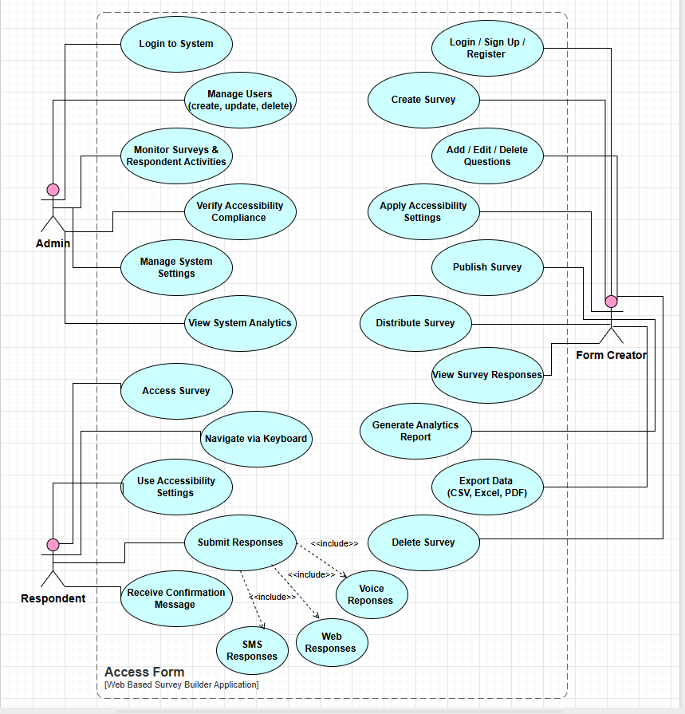

Usage Scenarios:

UC-01 — Login to System

Use Case Title | Login to System
Use Case ID | UC-01
Actor | Admin
Actions/Task Sequence | 1. Open AccessForm admin login page.  2. Enter username and password.  3. Click the “Login” button.  4. System verifies credentials.  5. Admin dashboard loads.
Description | This use case allows an administrator to log into the system securely to access all admin functionalities.
Pre-Condition | Admin has a valid registered account.
Post-Condition | Admin is successfully logged into the system and redirected to the admin dashboard.
Alternative Paths | Admin selects “Forgot Password” to recover login details.
Exceptions | Incorrect credentials, account disabled, server error.
Author | bc220404835 (Farah Murtaza)

UC-02 — Manage Users (Create, Update, Delete)

Use Case Title | Manage Users
Use Case ID | UC-02
Actor | Admin
Actions / Task Sequence | 1. Admin logs in.  2. Open the “User Management” panel.  3. Views list of registered users.  4. Adds, updates, or deletes user accounts.  5. System saves changes.
Description | Allows the admin to manage all system users by creating accounts, updating details, or deleting inactive/invalid accounts.
Pre-Condition | Admin must be logged in.
Post-Condition | User data is updated or stored successfully in the system.
Alternative Paths | Admin filters users by type or role.
Exceptions | System fails to update the database, missing mandatory fields.
Author | bc220404835 (Farah Murtaza)

UC-03 — Monitor Surveys & Respondent Activities

Use Case Title | Monitor Surveys & Respondent Activities
Use Case ID | UC-03
Actor | Admin
Actions / Task Sequence | 1. Admin opens the dashboard.  2. Views list of all surveys.  3. Checks activity logs and respondent participation.  4. Reviews survey performance.
Description | This use case enables the admin to view the activity of surveys and respondents for monitoring and system supervision.
Pre-Condition | Admin logged into the system.
Post-Condition | Activity insights displayed successfully.
Alternative Paths | Admin filters data by date range or survey ID.
Exceptions | Data loading failure due to server issues.
Author | bc220404835 (Farah Murtaza)

UC-04 — Verify Accessibility Compliance

Use Case Title | Verify Accessibility Compliance
Use Case ID | UC-04
Actor | Admin
Actions / Task Sequence | 1. Admin opens the “Accessibility Compliance” module.  2. System lists surveys with a compliance score.  3. Admin reviews issues.  4. Marks non-compliant surveys for correction.
Description | Ensures that all surveys created meet WCAG, ARIA, and accessibility guidelines before or after publishing.
Pre-Condition | At least one survey exists.
Post-Condition | Accessibility issues are identified and saved for correction.
Alternative Paths | Admin auto-runs accessibility audit.
Exceptions | Compliance scanner unavailable, incorrect survey metadata.
Author | bc220404835 (Farah Murtaza)

UC-05 — Manage System Settings

Use Case Title | Manage System Settings
Use Case ID | UC-05
Actor | Admin
Actions / Task Sequence | 1. Admin opens the settings panel.  2. Modifies configurations (themes, accessibility defaults, system preferences).  3. Saves changes.
Description | Allows admin to manage global system configurations related to accessibility defaults, themes, notifications, and system behavior.
Pre-Condition | Admin logged in.
Post-Condition | Updated settings applied system-wide.
Alternative Paths | Admin resets settings to default.
Exceptions | Invalid configurations, system settings fail to save.
Author | bc220404835 (Farah Murtaza)

UC-06 — View System Analytics

Use Case Title | View System Analytics
Use Case ID | UC-06
Actor | Admin
Actions / Task Sequence | 1. Admin selects “Analytics”.  2. System displays charts and activity statistics.  3. Admin analyzes trends.
Description | Provides admin an overview of platform usage, survey activity, user participation, and general insights.
Pre-Condition | System contains analytics data.
Post-Condition | Analytics displayed successfully.
Alternative Paths | Admin filters analytics by time or user type.
Exceptions | No data available, chart rendering errors.
Author | bc220404835 (Farah Murtaza)

  - UC-07 — Login / Sign Up / Register

Use Case Title | Login / Sign Up / Register
Use Case ID | UC-07
Actor | Form Creator
Actions / Task Sequence | 1. Open AccessForm.  2. Choose “Login” or “Sign Up”.  3. Enter required credentials.  4. Submit form.  5. System authenticates the user and opens the Form Creator dashboard.
Description | The form creator registers or logs in to access survey creation and management features.
Pre-Condition | Must have a valid account to log in; registration must be completed for first-time users.
Post-Condition | Form Creator dashboard is displayed.
Alternative Paths | Password recovery, resend verification email.
Exceptions | Invalid credentials, email already registered, server timeout.
Author | bc220404835 (Farah Murtaza)

  - UC-08 — Create Survey

Use Case Title | Create Survey
Use Case ID | UC-08
Actor | Form Creator
Actions / Task Sequence | 1. Open “Create Survey”.  2. Provide survey title and description.  3. Select structure or template.  4. Save basic survey layout.
Description | Allows the form creator to start a new survey and set up its basic structure.
Pre-Condition | Form creator must be logged in.
Post-Condition | A new survey draft is created in the system.
Alternative Paths | Use a predefined accessibility template.
Exceptions | Survey title missing, unable to save due to system error.
Author | bc220404835 (Farah Murtaza)

  - UC-09 — Add / Edit / Delete Questions

Use Case Title | Add / Edit / Delete Questions
Use Case ID | UC-09
Actor | Form Creator
Actions / Task Sequence | 1. Select a survey.  2. Click “Add Question”.  3. Choose question type (MCQs, text, rating, file upload).  4. Edit questions if needed.  5. Delete unwanted questions.
Description | Allows form creators to manage the questions within their survey.
Pre-Condition | A survey draft must already exist.
Post-Condition | Updated list of questions stored in the system.
Alternative Paths | Duplicate an existing question.
Exceptions | Invalid question type, failed to save.
Author | bc220404835 (Farah Murtaza)

  - UC-10 — Apply Accessibility Settings

Use Case Title | Apply Accessibility Settings
Use Case ID | UC-10
Actor | Form Creator
Actions / Task Sequence | 1. Open accessibility panel.  2. Enable keyboard navigation.  3. Add ARIA labels to fields.  4. Apply high-contrast or dyslexia-friendly themes.  5. Save settings.
Description | Ensures the survey meets WCAG 2.1 and ARIA accessibility standards.
Pre-Condition | Survey must be created.
Post-Condition | Accessibility settings are saved and applied to the survey.
Alternative Paths | Import an accessibility configuration preset.
Exceptions | Invalid ARIA attributes, unsupported themes.
Author | bc220404835 (Farah Murtaza)

  - UC-11 — Publish Survey

Use Case Title | Publish Survey
Use Case ID | UC-11
Actor | Form Creator
Actions / Task Sequence | 1. Open survey.  2. Click “Publish”.  3. System validates accessibility.  4. Survey becomes live.
Description | Enables the creator to publish their survey for respondents to access.
Pre-Condition | Survey must be complete and pass accessibility checks.
Post-Condition | Survey is live and accessible to respondents.
Alternative Paths | System suggests accessibility fixes before publishing.
Exceptions | Survey fails compliance, internet or server errors.
Author | bc220404835 (Farah Murtaza)

  - UC-12 — Distribute Survey

Use Case Title | Distribute Survey
Use Case ID | UC-12
Actor | Form Creator
Actions / Task Sequence | 1. Obtain survey link.  2. Share via web.  3. Enable voice or SMS participation (system-supported).
Description | Allows form creators to share the published survey with respondents.
Pre-Condition | Survey must be published.
Post-Condition | Respondents receive access to the survey.
Alternative Paths | Embed survey in a webpage or email.
Exceptions | Invalid survey link, sharing system unavailable.
Author | bc220404835 (Farah Murtaza)

  - UC-13 — View Survey Responses

Use Case Title | View Survey Responses
Use Case ID | UC-13
Actor | Form Creator
Actions / Task Sequence | 1. Go to “Responses”.  2. View list of respondent entries.  3. Filter or sort responses.  4. Read detailed entries.
Description | Allows the creator to see all responses submitted for their survey.
Pre-Condition | Survey has at least one response.
Post-Condition | Responses loaded successfully for review.
Alternative Paths | Apply filters (date, respondent, question).
Exceptions | No responses, data display error.
Author | bc220404835 (Farah Murtaza)

  - UC-14 — Generate Analytics Report

Use Case Title | Generate Analytics Report
Use Case ID | UC-14
Actor | Form Creator
Actions / Task Sequence | 1. Open “Analytics”.  2. View charts and graphs.  3. Interpret statistical results.
Description | Produces accessible charts and summaries of responses for creator review.
Pre-Condition | Responses must exist.
Post-Condition | Analytics displayed and accessible.
Alternative Paths | Change chart type.
Exceptions | Graph rendering failures.
Author | bc220404835 (Farah Murtaza)

  - UC-15 — Export Data (CSV, Excel, PDF)

Use Case Title | Export Data
Use Case ID | UC-15
Actor | Form Creator
Actions / Task Sequence | 1. Open export panel.  2. Choose format (CSV, Excel, PDF).  3. Download file.
Description | Allows creators to export survey responses into multiple formats.
Pre-Condition | Survey responses must exist.
Post-Condition | File successfully downloaded.
Alternative Paths | Export filtered responses only.
Exceptions | File generation error, insufficient permissions.
Author | bc220404835 (Farah Murtaza)

  - UC-16 — Delete Survey

Use Case Title | Delete Survey
Use Case ID | UC-16
Actor | Form Creator
Actions / Task Sequence | 1. Open survey list.  2. Select survey.  3. Click “Delete”.  4. Confirm deletion.
Description | Removes the survey and all related data from the system.
Pre-Condition | Form creator must be logged in.
Post-Condition | Survey removed from system.
Alternative Paths | Move survey to archive instead of deleting.
Exceptions | Survey locked, system error while deletion.
Author | bc220404835 (Farah Murtaza)

UC-17 — Access Survey

Use Case Title | Access Survey
Use Case ID | UC-17
Actor | Respondent
Actions / Task Sequence | 1. Open survey link via web, mobile, or screen reader.  2. System loads a high-contrast and accessible interface.  3. Respondent views instructions and begins a survey.
Description | Allows respondents to access the survey using their preferred device or assistive technology.
Pre-Condition | Survey must be published and accessible.
Post-Condition | Survey layout is successfully displayed for the respondent.
Alternative Paths | Open survey through embedded pages in email or website.
Exceptions | Invalid link, accessibility failure, server unavailable.
Author | bc220404835 (Farah Murtaza)

UC-18 — Navigate via Keyboard

Use Case Title | Navigate via Keyboard
Use Case ID | UC-18
Actor | Respondent
Actions / Task Sequence | 1. Press TAB to move between fields.  2. Use Enter/Space to select options.  3. Shift+Tab to return to the previous field.  4. System announces fields through ARIA roles.
Description | Ensures respondents with motor or visual disabilities can navigate without a mouse.
Pre-Condition | Survey must support keyboard-only navigation and ARIA labels.
Post-Condition | User successfully navigates the entire survey using keyboard interactions.
Alternative Paths | Use assistive switch devices (treated as keyboard input).
Exceptions | Focus trap issues, unresponsive keyboard navigation.
Author | bc220404835 (Farah Murtaza)

UC-19 — Use Accessibility Settings

Use Case Title | Use Accessibility Settings
Use Case ID | UC-19
Actor | Respondent
Actions / Task Sequence | 1. Enable high-contrast mode.  2. Turn on dyslexia-friendly font mode.  3. Enable screen reader enhancements.  4. System applies accessibility settings instantly.
Description | Allows respondents to customize the survey interface for their disability or preference.
Pre-Condition | Accessibility settings must be available and configurable.
Post-Condition | Survey is visually and functionally adjusted for respondent needs.
Alternative Paths | System automatically applies accessibility settings based on browser preferences.
Exceptions | Setting fails to apply due to unsupported browser or script error.
Author | bc220404835 (Farah Murtaza)

UC-20 — Submit Responses (includes Web, SMS, Voice Methods)
(Web Responses, Voice Responses, SMS Responses are included inside this single use case and will NOT have separate usage scenarios.)

Use Case Title | Submit Responses
Use Case ID | UC-20
Actor | Respondent
Actions / Task Sequence | Web Submission:  1. Fill out survey fields.  2. Review answers.  3. Click “Submit”.  SMS Submission (Included):  1. Receive questions via SMS.  2. Reply with answer text/number.  3. System records response.  Voice Submission (Included):  1. Respondent speaks answers.  2. Speech-to-text converts responses.  3. System confirms each entry.  Final Step: System stores all responses in database.
Description | Allows respondents to submit answers using web forms, SMS messaging, or voice input to support accessibility for all users.
Pre-Condition | Survey must be accessible and valid. Respondents must complete required fields.
Post-Condition | Responses stored in database; confirmation message sent to respondent.
Alternative Paths | Respondent edits answers before final submission.
Exceptions | Incomplete required fields, SMS delivery issues, microphone failure, speech recognition error.
Author | bc220404835 (Farah Murtaza)

UC-21 — Receive Confirmation Message

Use Case Title | Receive Confirmation Message
Use Case ID | UC-21
Actor | Respondent
Actions / Task Sequence | 1. Respondent completes and submits the survey (via web, SMS, or voice).  2. System validates the submission.  3. System generates a confirmation message (on-screen for web, SMS reply for SMS, or audio/text confirmation for voice).  4. System displays/sends confirmation including submission ID or summary (if enabled).
Description | Confirms to the respondent that their submission was received and recorded successfully, providing a reference (ID or brief summary) and optionally next steps or a thank-you message.
Pre-Condition | Respondent has completed the survey and initiated submission; system has network connectivity to send confirmations (for SMS/voice).
Post-Condition | Respondent receives a confirmation; the system logs the confirmation event and links it to the stored response.
Alternative Paths | 1. If the respondent opted out of confirmations, the system only stores the response without sending a message.  2. For anonymous surveys, the confirmation may be generic without personal identifiers.
Exceptions | 1. Confirmation fails to send due to network/SMS gateway issues.  2. System validation fails (incomplete required fields) — no confirmation sent and user prompted to correct errors.  3. Voice confirmation is not possible due to TTS or telephony failure.
Author | bc220404835 (Farah Murtaza)

Adopted Methodology

Adopted Methodology which we will use for the development of the project (AccessForm) which is a web based survey builder. We have adopted the VU Process Model which is the combination of Waterfall Model and Spiral Model. The VU Process Model will combine the benefits of Waterfall and Spiral methodologies.

Waterfall Model

For this project, the Waterfall Model has been adopted due to its structured and sequential approach, where each phase cascades into the next like a waterfall. This model is also referred to as the Linear Sequential Model. The model follows a linear flow in which each phase must be completed and documented before moving to the next. This ensures clarity, proper planning, and well-defined deliverables.
The Waterfall Model includes the following phases:
- Requirement Analysis: System requirements are gathered from users and documented as the official specification.
- System & Software Design: An overall system architecture is created, and software components are designed based on the requirements.
- Implementation & Unit Testing: The design is converted into code, and each module is individually tested for correctness.
- Integration & System Testing: All modules are integrated and tested as a complete system to ensure all requirements are met.
- Operation & Maintenance: The system is deployed for real use. Errors are corrected, improvements are made, and new features may be added.
The Waterfall Model ensures complete documentation, making maintenance easier. However, client feedback is received late in the process, which may lead to costly revisions if requirements were misunderstood. Despite this, its clear structure makes it suitable for projects with well-defined requirements—such as this one.

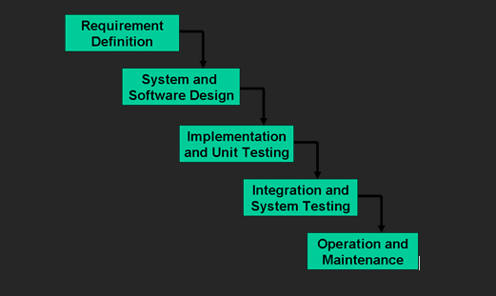

Spiral Model

The Spiral Model, developed by Barry Boehm, focuses on risk reduction throughout the software development process. Since software projects often face uncertainties—such as loss of key team members or changes in organizational stability—the model incorporates risk analysis at every stage.
The Spiral Model can be viewed as an extension of the Waterfall Model with added emphasis on risk assessment. Each cycle of the spiral includes:
- Objective Setting (Determine Objectives): Identifying the goals for the current phase.
- Alternative Solutions & Risk Analysis (Identify and Resolve Risks): Evaluating different approaches and analyzing potential risks.
- Development & Verification (Development and Test): Building prototypes, designing, or implementing the system depending on the phase.
- Planning the Next Iteration: Reviewing progress and planning the next cycle of the spiral.
The model has two dimensions:
- Radial dimension: Represents the cumulative cost.
- Angular dimension: Represents progress through the development lifecycle.
The spiral continues until the final product is completed. If at any point a risk cannot be mitigated, the project may be terminated early to avoid further loss.

Strengths and Limitations
- The model’s primary strength is its strong focus on risk management, making it suitable for large and complex projects.
- The iterative structure allows flexible testing, continuous evaluation, and smooth transition between development and maintenance.
- However, the Spiral Model is generally applicable only for large, in-house software projects, as it requires significant expertise in risk analysis and is more costly compared to linear models.

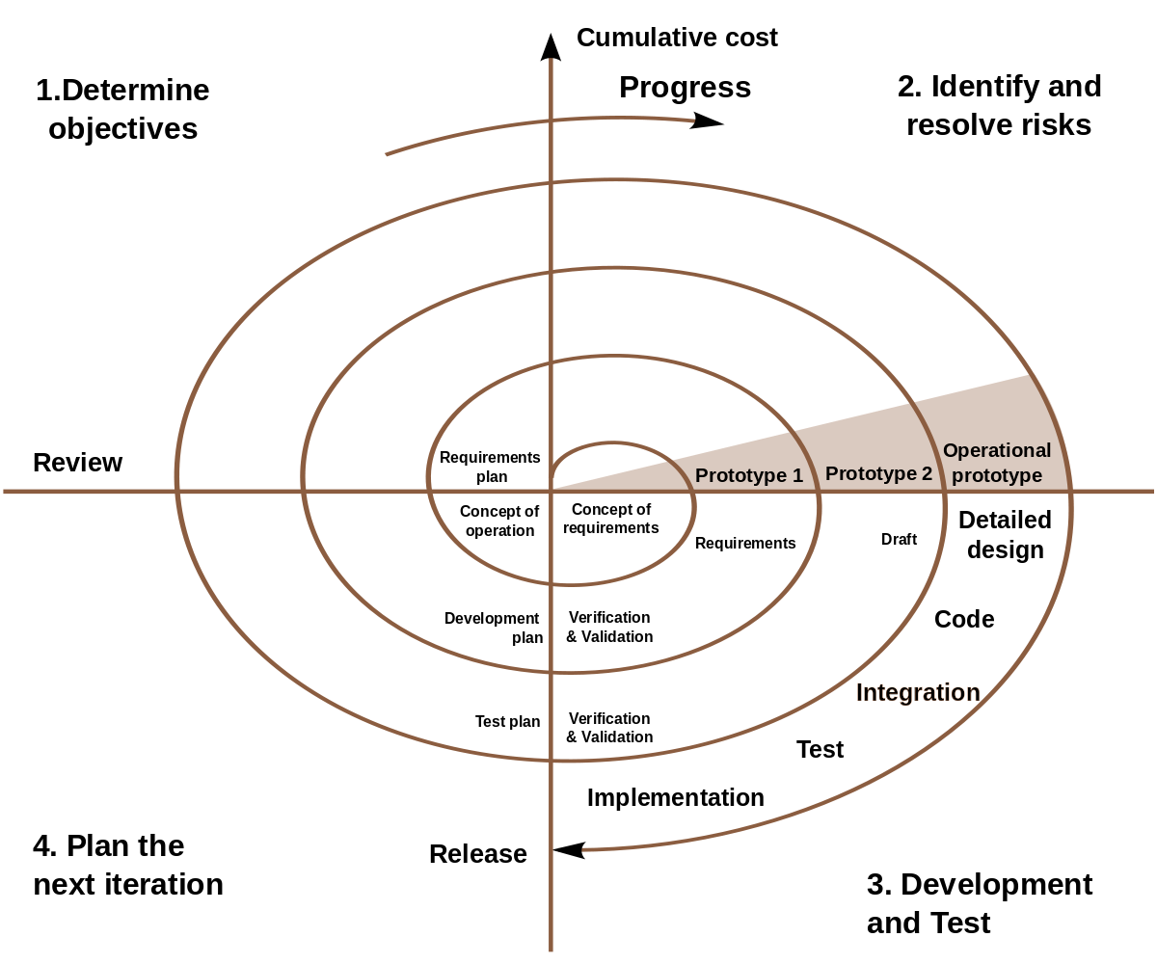

VU process Model

The VU Process Model is a structured, documentation-focused approach used in many Virtual University projects. It follows a step-by-step workflow where each phase is completed and approved before moving to the next.
The phases include:
- Requirements Definition
- System and Software Design
- Implementation and Unit Testing
- Integration and System Testing
- Operation and Maintenance
This model ensures clarity, proper documentation, and controlled development, but it offers limited flexibility for changes during the process.The strength of this model is that it ensures complete documentation, provides a controlled and systematic development flow, suitable for academic and structured software projects.

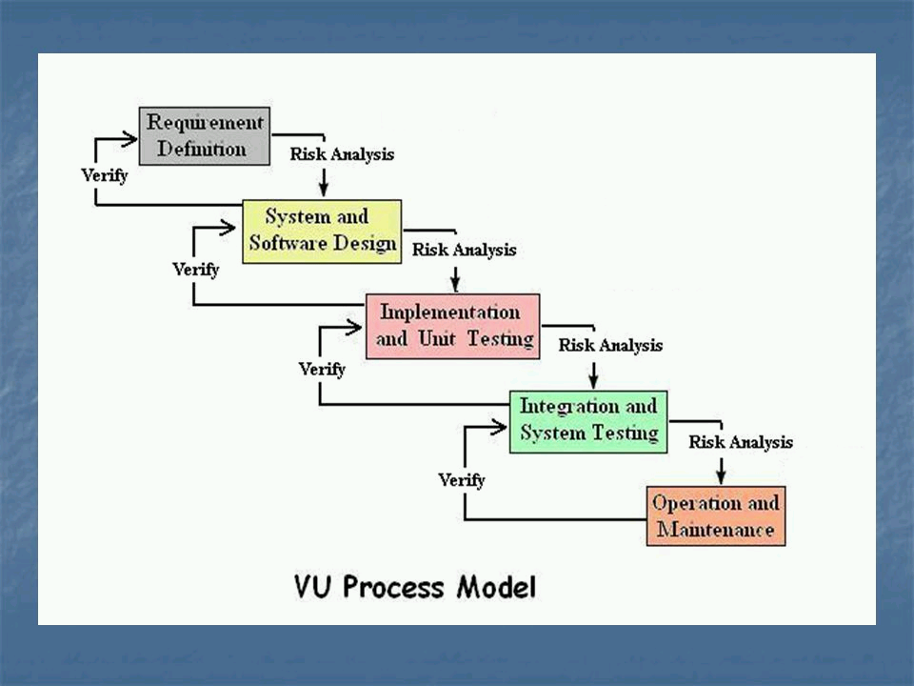

5.4 Reasons for choosing the Methodology

- The chosen methodology allows us to benefit from the strengths of both structured and iterative approaches.
- It provides a sequential flow with the option of backward repetition when necessary.
- We aim to achieve the linear clarity of the Waterfall Model along with the iterative improvement and risk reduction aspects of the Spiral Model.
- The VU Process Model supports phase-based development, enabling us to complete the project in an organized and manageable way.
- All activities are performed in a clear sequence, which ensures proper documentation and controlled progress.
- If corrections or improvements are required at any stage, the model allows repetition whenever needed, making it flexible yet structured.

Work Plan (Use MS Project to create Schedule/Work Plan)

Work Plan

The Work plan is the backbone of any project. If our plan is suitable for the project then the project will be completed within time and budget. The project plan shows the tasks and responsibilities distribution. We plan the software development progress mainly.

Detailed Project Schedule:

The detailed day wise allocation to each phase is represented below.

Gantt Chart

